**Fanka Shundovska**

**IntelliJ – JAVA IF ELSE Extra Homework AT06**

1. Write a Java program to get a number and print whether it is positive or negative.

public class PositiveNegativeNumbers {  
  
 public static void main(String[] args) {  
  
 int num = 912;  
  
 if (num > 0) {  
 System.*out*.println("The number is positive.");  
 } else if (num < 0) {  
 System.*out*.println("The number is negative.");  
 } else {  
 System.*out*.println("The number is zero.");  
 }  
 }  
}

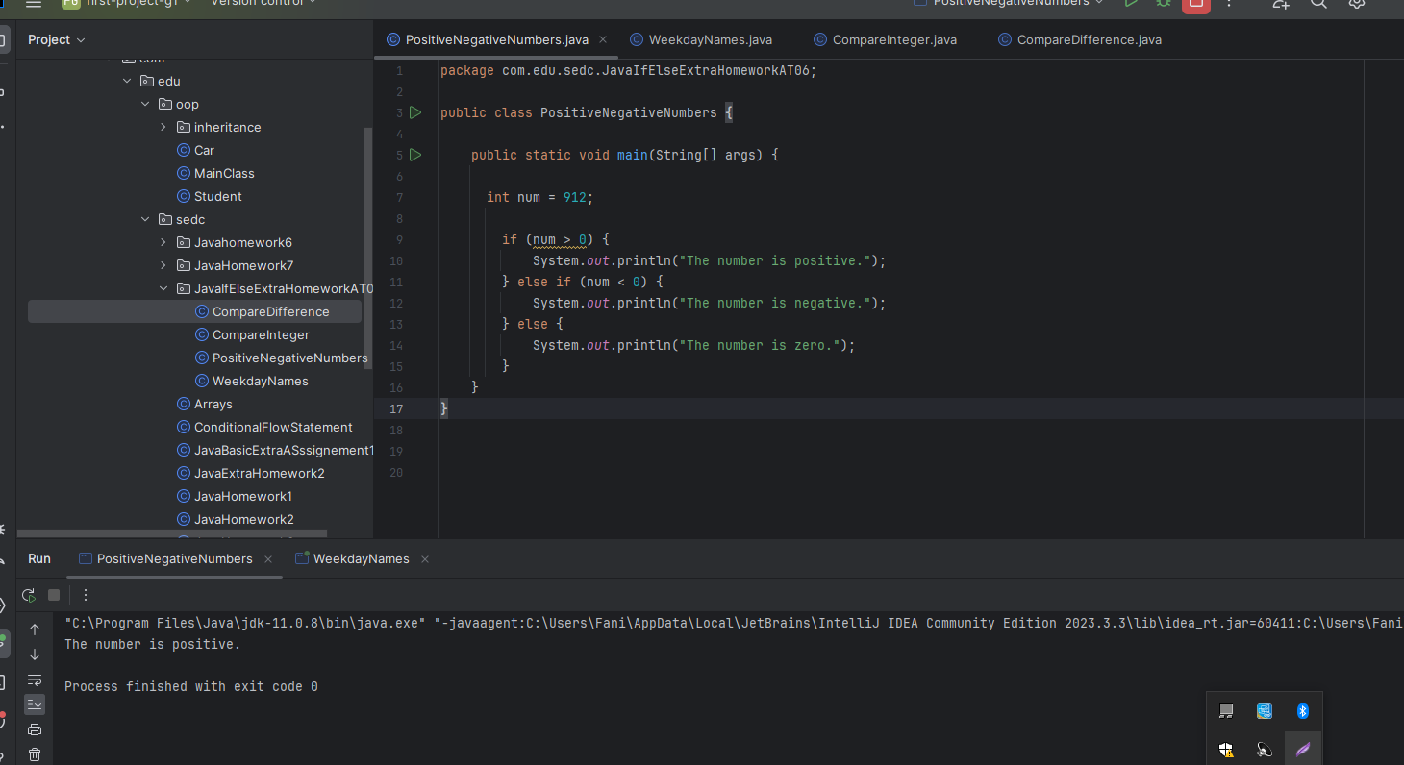

2. Write a program with two int variables, int x and int y, and give each one a value. Depending on their values, print “x is bigger than y”, “x is smaller than y”, or “x and y are the same”. Change the values and run the program a few times to check it works.

package com.edu.sedc.JavaIfElseExtraHomeworkAT06;  
  
public class CompareInteger {  
  
 public static void main(String[] args) {  
  
 int x = 10;  
 int y = 5;  
  
 if (x > y) {  
 System.*out*.println("x is bigger than y.");  
 } else if (x < y) {  
 System.*out*.println("x is smaller than y.");  
 } else {  
 System.*out*.println("x and y are the same.");  
 }  
  
 }  
}

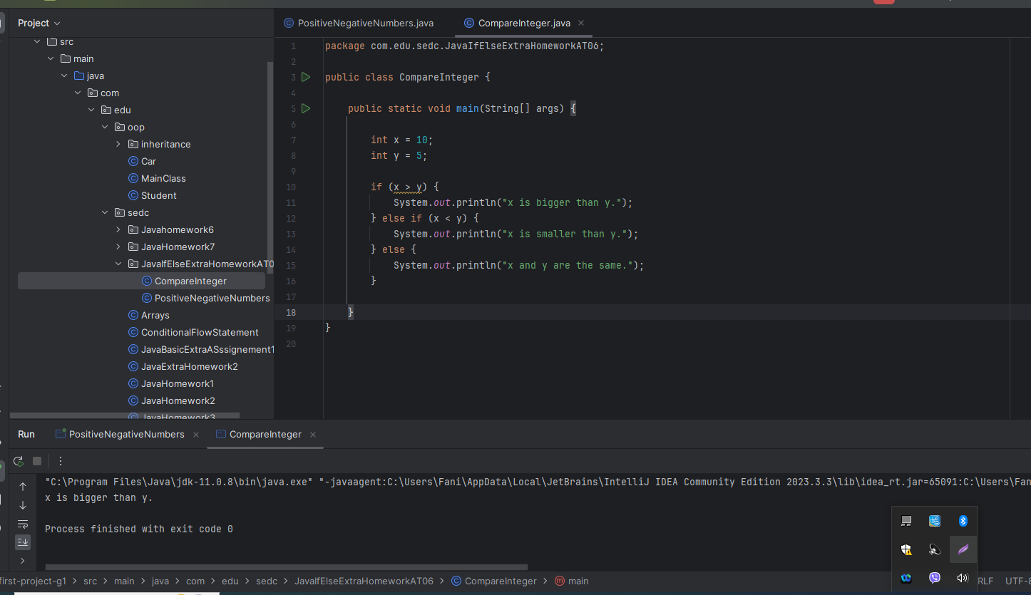

3. Write a Java program that when entering an integer between 1 and 7 displays the name of the weekday.

package com.edu.sedc.JavaIfElseExtraHomeworkAT06;  
  
import java.util.Scanner;  
  
public class WeekdayNames {  
  
 public static void main(String[] args) {  
  
 int day = 4;  
 String dayOfWeek = Integer.*toString*(day);  
  
 switch (dayOfWeek) {  
 case "1":  
 System.*out*.println("Monday");  
 break;  
 case "2":  
 System.*out*.println("Tuesday");  
 break;  
 case "3":  
 System.*out*.println("Wednesday");  
 break;  
 case "4":  
 System.*out*.println("Thursday");  
 break;  
 case "5":  
 System.*out*.println("Friday");  
 break;  
 case "6":  
 System.*out*.println("Saturday");  
 break;  
 case "7":  
 System.*out*.println("Sunday");  
 break;  
 default:  
 System.*out*.println("Invalid input");  
 break;  
 }  
  
 Scanner sc = new Scanner(System.*in*);  
 System.*out*.print("The day number is: 4");  
 int dayNumber = sc.nextInt();  
  
 String[] weekdays = {"Sunday", "Monday", "Tuesday", "Wednesday", "Thursday", "Friday", "Saturday"};  
  
 if (dayNumber >= 1 && dayNumber <= 7) {  
 System.*out*.println("Weekday: " + weekdays[dayNumber - 1]);  
 } else {  
 System.*out*.println("Invalid input. Please enter a number between 1 and 7.");  
 }  
 }  
}

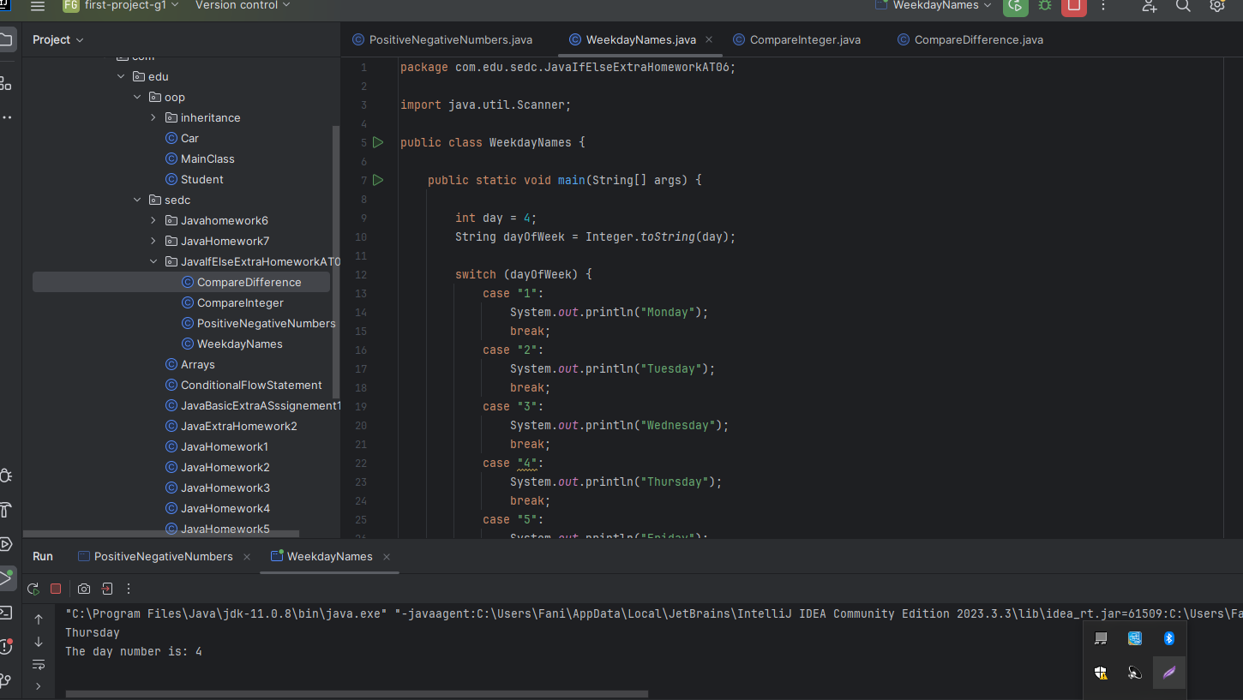

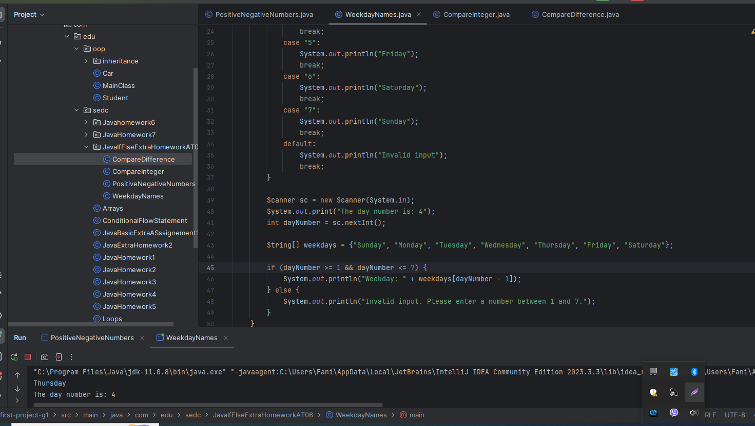

4. Modify the program from Exercise 2 so it also prints the difference between x and y.

package com.edu.sedc.JavaIfElseExtraHomeworkAT06;  
  
public class CompareDifference {  
  
 public static void main(String[] args) {  
 int x = 10;  
 int y = 5;  
  
 if (x > y) {  
 System.*out*.println("x is bigger than y.");  
 } else if (x < y) {  
 System.*out*.println("x is smaller than y.");  
 } else {  
 System.*out*.println("x and y are the same.");  
 }  
  
 int difference = Math.*abs*(x - y);  
 System.*out*.println("Difference between x and y: " + difference);  
 }  
  
}

